**Name-Md. Rashid Aziz**

**Roll no. -2003013**

**Batch- C11**

**AIM**

Study arrays and String function

**Program1:**

Python program to

●Read an array and display

●Append a new item to the end of the array.

●To reverse the order of the items in the array (slice operator)

●Get the length in bytes of one array item

●To append items from another array

●Remove a specified item using the index from an array

●Insert a specified item at the specified position in the array

**Theory**

An array is a special variable, which can hold more than one value at a time.

You can use the for in loop to loop through all the elements of an array.

You can use the append() method to add an element to an array.

You can use the pop() method to remove an element from the array.

You can also use the remove() method to remove an element from the array.

**Program:**

from array import *

arr = array('i',[]);

print("enter the size of array");

n = int(input());

for i in range(n):

    a = int(input());

    arr.append(a);

print(arr);

arr.append(7);

print(arr[::-1]);

print(arr[0])

x = len(arr)

print("size of one element of array=",arr.itemsize);

arr1 = [100, 200];

arr2 = [101, 20];

# arr1.append(arr2) # Output: [1, 2, 3, [10, 20]]

arr1.extend(arr2) #Output[100, 200, 101, 20]

print(arr1);

a = int(input("Enter the element you want to delete:"));

try:

    ind = arr1.index(a);

    arr1.remove(a);

    print("Removed!!");

except:

    print("element not found")

print(arr1);

a = int(input("Enter the element you want to Insert:"));

b = int(input("Enter the index you want to Insert:"));

try:

    arr1.insert(b, a);

    print("inserted");

except:

    print("invalid index");

print(arr1);

**Output**

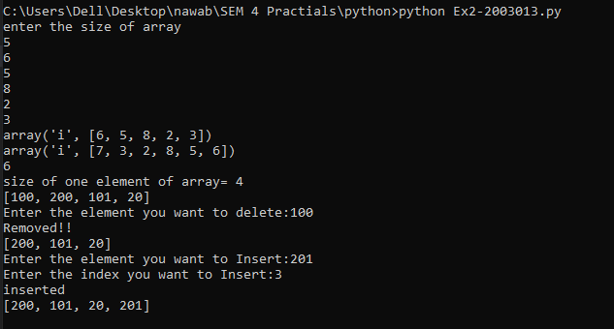

**Program 2:**

Python program to remove prime numbers from an array. Sample input arr[]={3,4,6,9,13,14,16,17} Output arr[]={4,6,9,13,16}

**Theory**

The sieve of Eratosthenes is one of the most efficient ways to find all primes smaller than n when n is smaller than 10 million or so

**Program:**

lst = [None] * 1000

for i in range(2,100):

    temp=i

    j = 2*i;

    if lst[i] == None:

        while j<1000:

            lst[j] = 1;

            j = j + temp

for i in range(1000):

    if lst[i] == None:

        print(f"{i} ",end='')

lst[2] = 1;

arr = [1, 2, 3 ,4, 5, 9,12 ,10,16,17,20];

for i in arr:

    if lst[i] == None:

        arr.remove(i);

print(arr);

**Output**

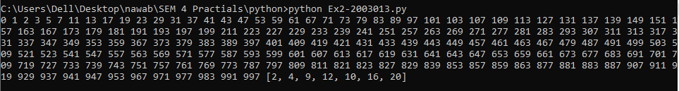

**Program 3:**

Python program to change all occurrences of a first character of a string to @ except for first occurrence.

Sample String : 'apple a day' Expected Result : 'apple @ d@y'

**Theory**

Strings in python are surrounded by either single quotation marks, or double quotation marks.

You can assign a multiline string to a variable by using three quotes.

Like many other popular programming languages, strings in Python are arrays of bytes representing unicode characters.

However, Python does not have a character data type, a single character is simply a string with a length of 1.

Square brackets can be used to access elements of the string.

To get the length of a string, use the len() function.

To check if a certain phrase or character is present in a string, we can use the keyword in.

To check if a certain phrase or character is NOT present in a string, we can use the keyword not in.

**Program:**

s = "apple a day";

flag = False;

ans = "";

for ch in range(0, len(s)):

    if ((s[ch] == "a") and (flag == True)):

        ans = ans + "@"

    elif ((s[ch] == "a") and (flag == False)):

        ans = ans + s[ch];

        flag = True;

    else:

        ans = ans + s[ch];

print(ans);

**Output**



**Program 4:**

Python Program

●to sort group of strings into alphabetical order

●to check whether entered string is palindrome or not

**Theory**

A palindrome is **a word, sentence, verse, or even number that reads the same backward or forward**.

**Program:**

s = input("Enter a string:");

print(sorted(s))

rev = s[::-1];

if s == rev:

    print("yes it is palindrome");

else:

    print("its not a palindrome")

**Output**

